Name: VŨ Minh Quan

Class : MINF15

HELP AUTOMATA PROGRAM

The GUI of My Program:

Video desmo the way to use my program: <https://www.youtube.com/watch?v=Ewlq12I4URg>

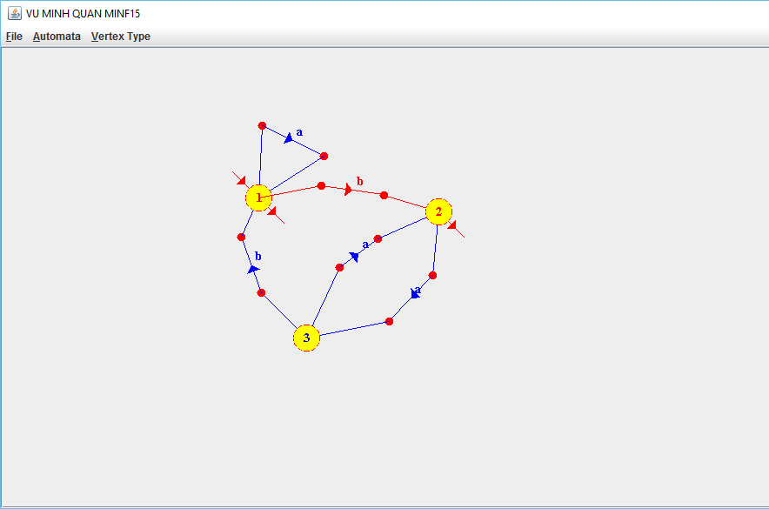

1. **Drawing mode:**

* Before draw a Vertex, choose type of Vertex in Vertex Type menu: initial directed edge, terminal directed edge, normal vertex, default value is Normal Vertex (the node is not initial or terminal Vertex), press on empty space in the software to create Normal Vertex
* Press and hold Alt + Left Mouse Button on a vertex and drag to another vertex. During the creation of an edge, press spacebar to add joint point with purpose connect between two vertex (maximum joint points between two vertex is 2)
* RightMouseButton press on joint point to delete it and edge contains it.
* RightMouseButton press on a vertex to delete it and edges have initial directed edge or terminal directed edge from its.
* LeftMouseButton on a vertex or joint point to move it.
* LeftMouseButton **press on a vertex and press numbers** ( 1, 2, 3,…) to **created label** **for vertex**.
* LeftMouseButton **press on a join point** and press characters ( a, b, c,…) to **created label for edge**.

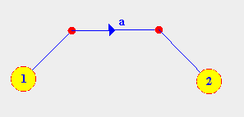

**Figure 1: Click to Vertex or Mid Point and press character to create label for Vertex and Edge**

1. **Save and load file:**

The software save automation to 2 file: automata.bin and export.xml:

After created automation, user choose save to file, automation will save to folder “Files” in source code folder with default name “automata.bin”, example in figure 2.

* Other option after created automation, user cho Save to XML file, automation will save to any folder in the computer with default name “export.xml”, example in figure 2.

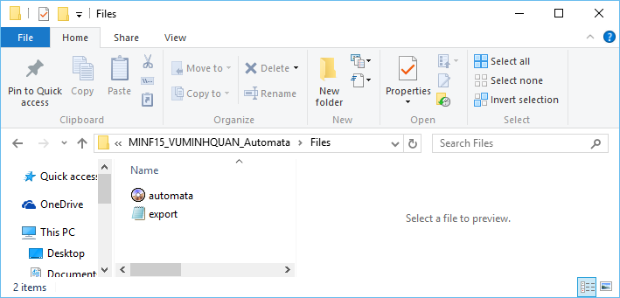

**Figure 2: Automata save to file in Files folder**

1. **Check the string accept by automation:**

Final feature of the software is check the string, when user choose the “Recognize Automata” in Automata Menu, dialog will be show and user has to input the string to check it accepted by automata.

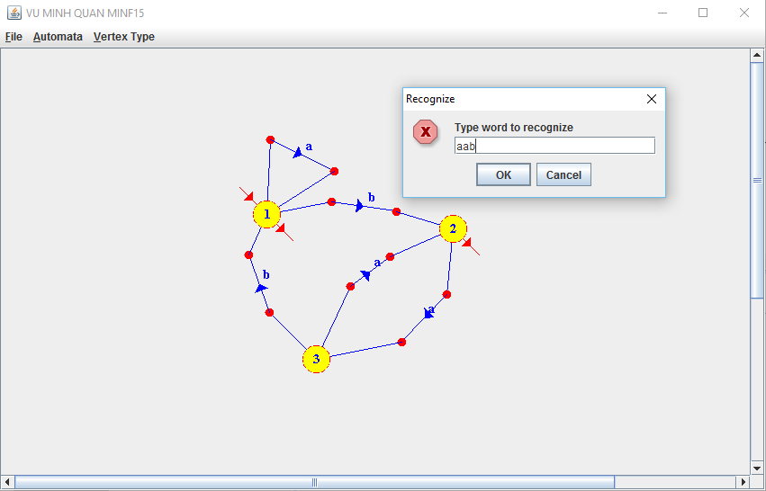

**Figure 3: Input the test string accept by Automata**